Customer service
From transactions to transformations

Christine Kreger & Kieran Hixon
Colorado State Library

What we want you to know

- It has been a few hard years with lots of constant change.

- Library work is people work; people can be difficult.

What we are going to do today

- Discuss ways staff have adapted over the last 2 years.

- Learn about the Transformation Model and how it applies to customer service

- Brainstorm what we intentionally want to carry forward.

Reflection: What is your favorite part about working at the library?

Types of Interactions

Responsive

Predictive

Encouraging

Engaging

Empowering

Reflection: Why do people come to the library?

The Spiral Model
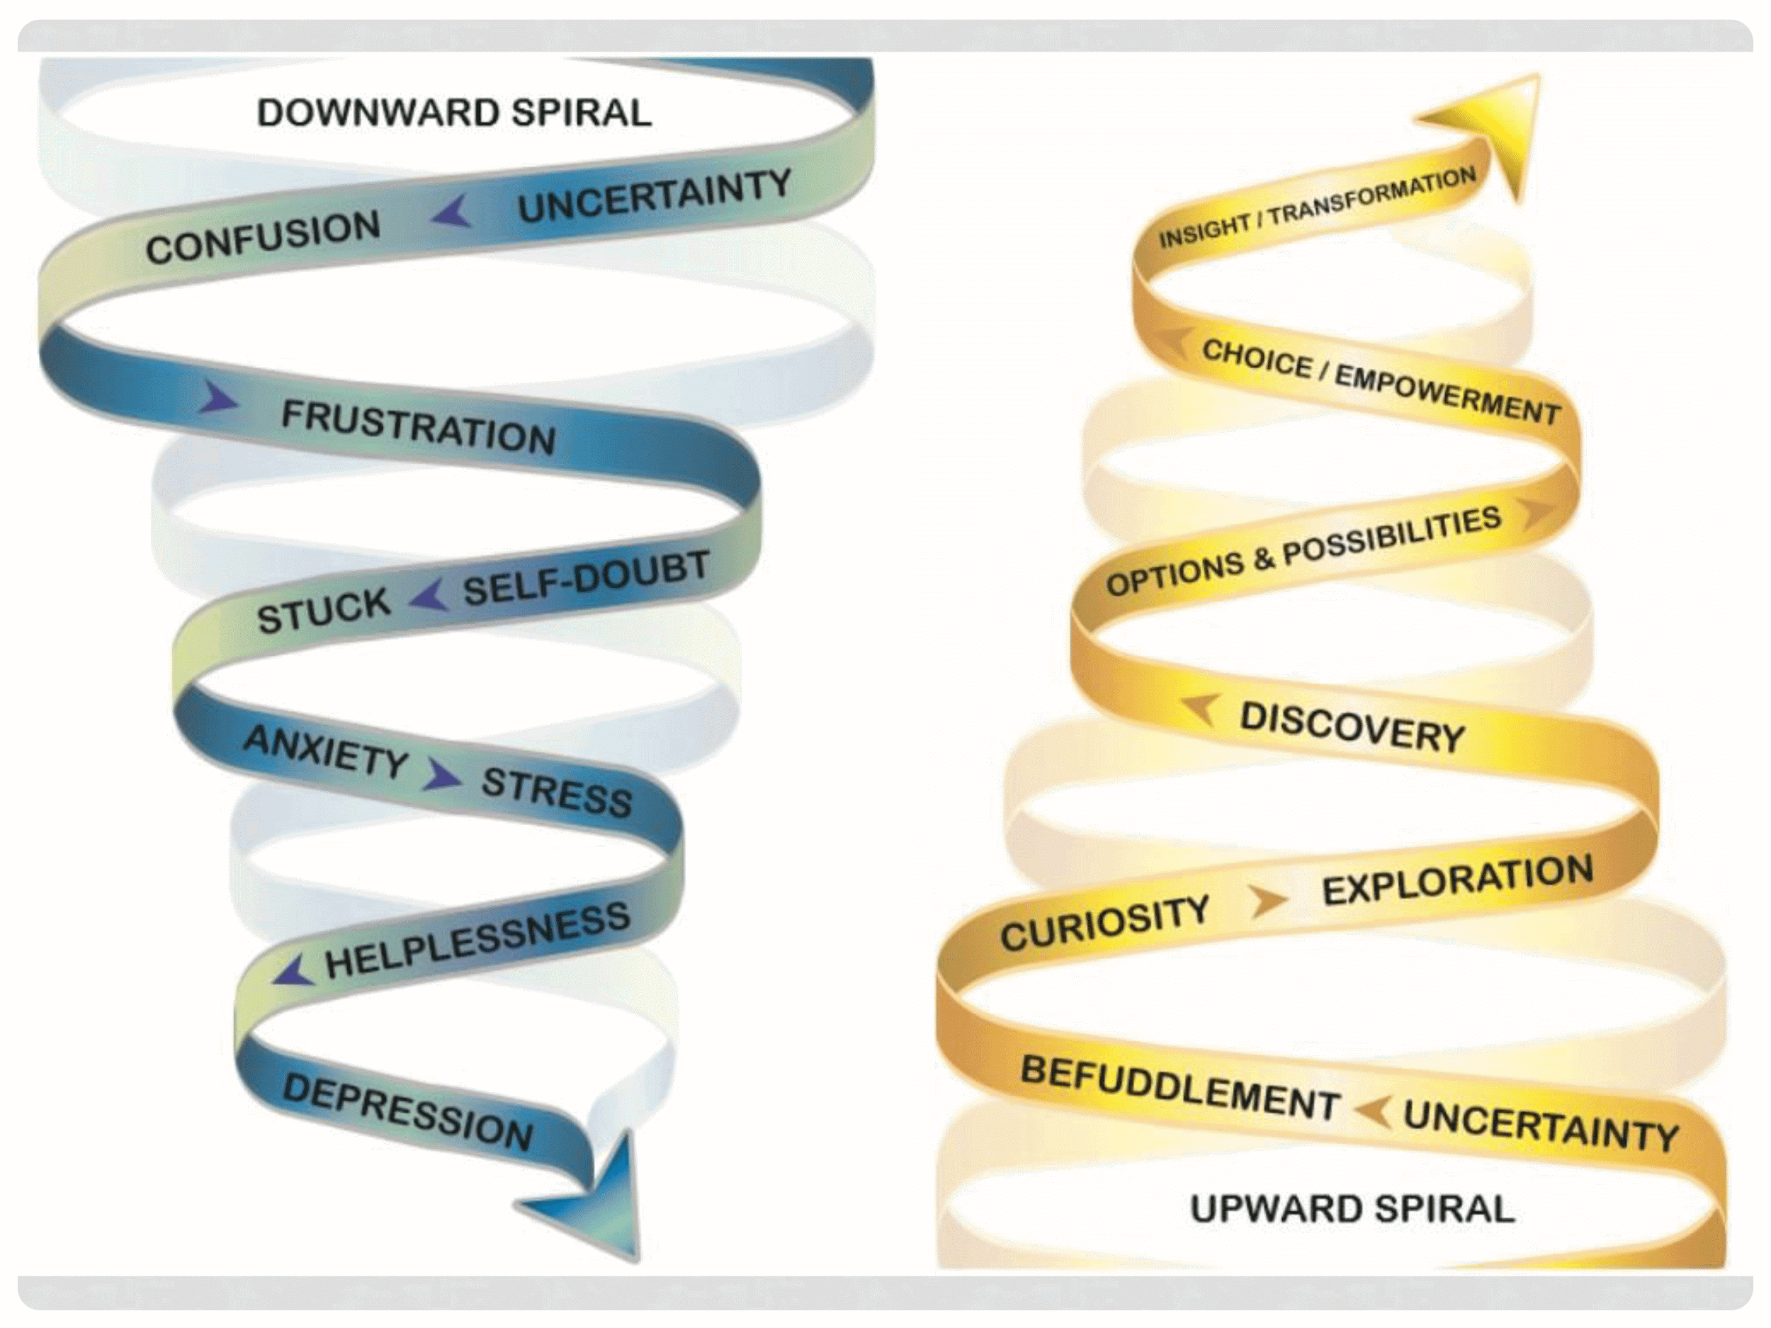
Reflection: How have you had to adapt at work?

Reflection: What worked well? What did not?

Reflection: How can we be intentional with what we keep?

Transformation Action Plan

- What is one thing from this session you would like to explore or learn more about?

- What is one thing you can commit to practicing in the next month to make your interactions more transformational?

- What are 2 things your organization can start, practice, or do more of to transform a service?

