Sticky Situations:
Patron Privacy and Customer Service

Christine Kreger
Colorado State Library

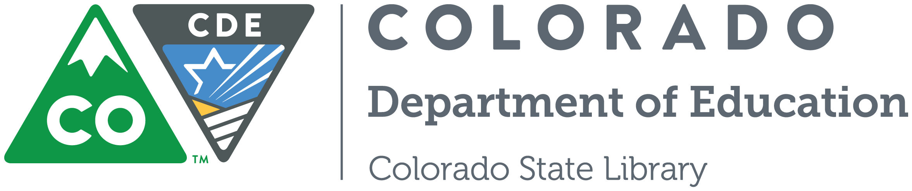
“Privacy is essential to the exercise of free speech, free thought, and free association.”
-Privacy Tool Kit

What is Privacy?

What is Confidentiality?

What are some examples of information that we need to keep confidential?

Colorado Library Law
Privacy of User Records  CRS 24-90-119 | Rough, non-legal summary of statute:  Privacy of user records*
- Except as set forth in subsection (2) of this section, a publicly supported library shall not disclose any record or other information that identifies a person as having requested or obtained specific materials or service or as otherwise having used the library.  - Records may be disclosed in the following instances:  - When necessary for the reasonable operation of the library;  - Upon written consent of the user;  - Pursuant to subpoena, upon court order, or where otherwise required by law;  - To a custodial parent or legal guardian who has access to a minor’s library card or its authorization number for the purpose of accessing by electronic means library records of the minor.  - Any library official, employee, or volunteer who discloses information in violation of this section commits a civil infraction and, upon conviction thereof, shall be punished by a fine of not more than three hundred dollars. | A public library may not disclose patron records or information about library use unless:  - Needed for library operations;  - The user consents;  - Required through subpoena or court order;  - A custodial parent/guardian has access to a minor’s library card or authorization number.  Discloser by a library official, employee or volunteer commits a class 2 felony offence, with up to a $300 fine if convicted.
*Consult with your respective city, county, or district for legal advice on, and implications of, Colorado Library Law, or call the Colorado State Library for additional information.
http://www.cde.state.co.us/cdelib/qgprivacy

When are we allowed to share confidential information?

When are we not allowed to share confidential information?

Library Policies

What does your library’s Patron Privacy Policy say?

Are there library procedures or guidelines related to your Patron Privacy Policy?

Scenarios

Scenario 1
In between helping patrons on the floor, you overhear two staff members talking about a patron near the circulation desk. “He is definitely a bit creepy! I bet he lives alone. He is just so awkward!” The other staff member responds by laughing, “I know, I helped him check out some items last week, and he was checking out books on dating and how to find your soulmate!”

- What makes this situation sticky? Where is the tension? Why is consistency important?

- What should you do? What should you say?

- They are talking near the self-checkout machines. Does this change your response?

- A mother complains that her child saw this patron looking at pornography on the computer. Does this change your response?

Scenario 2
A patron wants to know what is checked out on his wife’s card so that he can return the items while she is out of town.

- What makes this situation sticky? Where is the tension? Why is consistency important?

- What should you do? What should you say?

- The next time the patron comes in, he is asking to see what his 16-year-old daughter has checked out. When you check the daughter's account, you see that she checked out a book about teenage pregnancy. What should you do?

- One of the books on the child’s record is about dealing with a family member who is an alcoholic. What should you do?

Scenario 3
A frantic mom calls looking for her 11-year-old son, who did not show up after school. He loves the library, and she is wondering if you can page him, or look for him.

- What makes this situation sticky? Where is the tension? Why is consistency important?

- What should you do? What should you say?

- The son is a regular at the library, and he recently confided to you that there has been trouble at home. Does this change your response?

- You haven’t seen the son in over a week, which is unusual. Does this change your response?

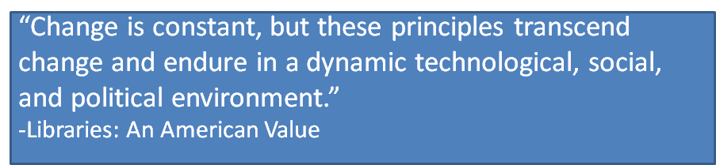
Resources

ALA Code of Ethics
https://www.ala.org/tools/ethics

ALA Bill of Rights
https://www.ala.org/advocacy/intfreedom/librarybill

ALA Privacy
https://www.ala.org/advocacy/privacy

ALA Privacy Field Guides
https://www.ala.org/advocacy/privacy/fieldguides

Bemis Public Library Privacy Policy
https://www.library.littletonco.gov/About-Us/Library-Information/Policies/Patron-Privacy-Policy

Colorado Library Law (PDF)
http://www.cde.state.co.us/cdelib/qgprivacy

Colorado Public Library Standards
http://www.cde.state.co.us/cdelib/standards/index

“Freedom is found through the portals of our nation’s libraries.”
- David McCullough

